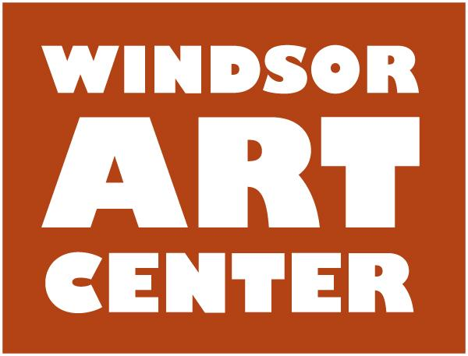

**Press Release**  Contact: Ken Fredette

Immediate - Wednesday, February 21, 2018 413-297-2470

**WINDSOR, CT** — The Windsor Art Center is pleased to announce its upcoming exhibition entitled *Art on the Tracks: A Celebration of the “Studio*,” which will run March 10 through April 21, 2018. This exhibition includes works by resident studio artists at Windsor Train Station including Andres Chaparro, a painter inspired by jazz; LeaAnn Cogswell, a representational sculptor of the human form; Cathy Doocy, a painter using the vernacular of landscape painting as a method for exploring composition and color; Elizabeth Gibbs, a writer and certified yoga therapist teacher; Che’ La’Mora, a visual artist, writer & marriage and family therapist; and JoeSam, a mixed-media artist reflecting African American culture.

**Free Opening reception** **on Saturday, March 10, from 5-7 pm.** The exhibition runs through April 21 at The Windsor Art Center, 40 Mechanic Street, Windsor, CT.

*Additional events during the exhibition:*

**Therapeutic yoga class for all levels • Saturday, March 31 • 2–3:30 pm • by Elizabeth Gibbs.** Elizabeth will teach you easy-to-learn postures, breathing exercises and meditation that you can do anywhere and anytime to help you manage stress and promote optimal health and relaxation. You can participate in this class on a mat or in a chair. The class is suitable for all ages and abilities. **FREE**

**Demo on painting landscapes from memory • Saturday, April 7, 1–2:30 pm • by Cathy Doocy.** Cathy will demonstration her process of recalling natural landscapes from memory, and the inner vision she then expresses in her paintings. **FREE**

**Art talk *and* demonstration on making mixed media art • Saturday, April 14 • 1–2:30 pm.** JoeSam will discuss his art theory, demonstrate his mixed media art form, and explain how he uses found materials in his work. **FREE**

**About the Artists:**

**Andres Chaparro** is a mixed media painter and collagist whose bold and expressive art is a visual representation of jazz music. "I work without premeditation simply following the path that each painting sets forth for me. Through my artwork I strive to create an example of ideas that reflect my desire to raise social consciousness, and cultural awareness.”

**LeaAnn Cogswell**is a sculptor devoted to the power that lies within the human form. "I consider it a great privilege to work regularly from life. Infinitely varied, the human figure is fascinating and amazingly beautiful, even in all its not-so-perfect forms. A powerful visual subject, it always holds new surprises.”

**Cathy Doocy** is a painter of contemporary landscapes. “In my work, the representation of a ‘landscape’ is not the final goal. Instead, I use the vernacular of landscape painting as a method for exploring composition and color. My work is about painting not landscape; about illusion not representation; about drawing not twigs and branches.”

**Elizabeth Gibbs** is a yoga therapist and writer. “My efforts focus on bringing yoga to populations that would not ordinarily find their way into a yoga studio. I have produced an introduction to Yoga Nidra CD and written a therapeutic yoga book for children with a companion manual for adults who work with children.”

**Che’ La’Mora** is a Heartbreak Coach with a degree in Marriage and Family Therapy offering support for people struggling with heartbreak and/or divorce. "I know how it feels to feel unheard, alone, or lost in emotions.” Her blog “Selfiie Chronicles” follows her journey as a divorced mom with two children; healing, self-love and recovery.

**JoeSam** is a mixed media artist, who prefers to use materials in the state in which they were found. “My work reflects the fact that I’m a Black artist. My colors, patterns, and designs are multi-faceted and combine many parallel elements in a single piece of work analogous to the way African derived music combines parallel rhythmic and melodic elements.”

*This exhibition is supported in part by the Greater Hartford Arts Council’s United Arts Campaign and in part by local businesses, organizations, and individuals from our community.*

For the latest information and details, visit our website at windsorartcenter.org or call 860-688-2528. Exhibition hours are: Thursday, 6:00 - 8:00 pm; Saturday, 10:00 am - 4:00 pm and Sunday, 11:00 am - 4:00 pm.

Located in Windsor, Connecticut, the Windsor Art Center is a nonprofit organization that promotes the visual and performing arts and presents visual art exhibits showcasing the works of a variety of artists working in diverse media and genres and hailing from throughout New England and beyond. Artist “talks” and children’s activities complete the annual programming. There is no charge to visit the gallery or the on-site gift shop which features locally made art. Parking is free and easily accessible.