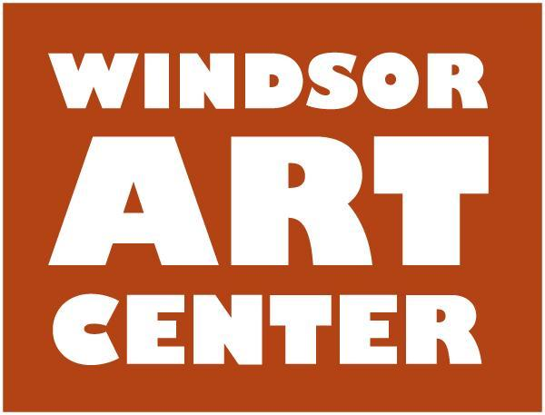

**Press Release**  Contact: Katherine Tolve

Immediate – AUGUST 21 860-748-0088

Windsor Art Center Opens *Piece By Piece*: Selected works by the MIA (Mothers In Art) Artist Collective

**On Saturday, September 16,** from 5 – 7 p.m., Windsor Art Center kicks off its 10th anniversary celebration with an opening reception for ***Piece By Piece: selected works from the Mothers In Art (MIA) Artist Collective***. This exhibit, which runs from September 16 through October 28, responds to the title question of Jacoba Urist’s May 21, 2015 article in *The New York Times*, “Why Can’t Great Artists Be Mothers?” Urist writes,

“The art world is full of enduring stereotypes… There’s the myth of the starving artist. The crazy artist. The hermit artist, And then there’s the childless artist – a woman (yes, she’s usually female) so fervidly dedicated to her craft that there’s no room in her life for motherhood....Kids and their constant battery of needs, the argument goes, are incompatible with true creativity. Art is supposed to be an all-consuming enterprise – and now modern parenting is too.”

Each of the multi-talented MIA artists represented in this exhibit approaches her creative practice in different ways, at different times, in varying mediums including photography, printmaking, painting, and collage. Each simultaneously defied the myth surrounding female artists with children. M.I.A does not allude to missing in action. For us, M.I.A. stands for all that we are, mothers in art, fully engaged in parenting *and* creative expression. Artist include: Katherine Tolve, Jess Franks, Cassia Cogger, Kathleen Woodward, Meredith Arcari, and Katrina Russo.

Several events/workshops will complement the exhibition.

* **Opening public family-friendly reception:** Saturday, September 16, 5:00 – 7:00 p.m. followed by, **“Art after dark,”** surprise entertainment and cocktails7 **–** 9:00 p.m. Free.
* **Donation Drive:** On behalf of the artists, Windsor Art Center will humbly be **accepting donations** at the opening, as well as throughout the exhibit, for My Sister’s Place, Inc. which provides shelter and services to women. In addition, 50% of sales on a selection of the artworks will be donated to My Sister’s Place.
* **Artist talk/book signing**: Sunday, September 17, 2:00 – 3:00 p.m. Artist Cassia Cogger will discuss her story circle techniques in watercolor and mixed media and sign copies of her book, "Creating Personal Mandalas.” Free
* **Little Artist Program:** Thursday mornings 10:00 – 11:00 a.m., September 21, 28, October 5 and 12.This mini program is intended for children ages 2-5 (older and younger siblings welcome!) Children will enjoy listening to stories and will create a craft. Led by artist/educator Katherine Tolve. Free
* **Jess Franks, Live Painting:** Saturday, September 23, 1:00 – 3:00 p.m. The public is invited to drop by the gallery and watch Jess creating one of her paintings. Free
* **Film night, *Indie Kindrid,***directed by **Jen Lee:** Friday, September 29, 6:00 p.m.; pizza and popcorn. Filmmaker Jen Lee profiles ten independent artists, who turn friendships and virtual connections into real world collaborations. She explores the benefits and challenges of creating independently, how to find like-minded others and what's possible when makers join forces to create together. Free
* **Mixed media collage workshop, *Through Your Eyes*:** September 30, 1:00 – 3:00 p.m. Create mixed media collage artwork highlighting your neighborhood and create a sense of place with artist Meredith Arcari. Cost: $30 plus material fee of $10.
* **Intro to Linocut printmaking:** Friday. October 13, 5:00 – 9:00. Join us for a Spooky intro to lino block carving and printing. Printmaker Kathleen Woodward takes you through the process of designing and carving your own linoleum block to create a small edition printed image. Walk away with your block carving and a beautiful suite of unique and editioned prints, and the skills to make more! Cost: $40 plus material fee of $35
* **Embrace yourself mini photo shoot with Katrina Russo:** Thursday, October 19; Friday, October 20; Sunday, October 22. Mini photoshoot for women to help engage and embrace their sense of self confidence. Time slots available. Please call 860-604-7075.
* **Windsor Art Center 10th anniversary celebration** and last chance to view exhibition: Saturday, October 28, 5:00 – 7:00 p.m.

*This exhibition is sponsored by The Ensworth Foundation of the Bank of America Philanthropic Solutions*

Located in Windsor, Connecticut, the Windsor Art Center is a nonprofit organization that promotes the visual and performing arts and presents visual art exhibits showcasing the works of a variety of artists working in diverse media and genres and hailing from throughout New England and beyond. Artist talks and children’s activities complete the annual programming. There is no charge to visit the gallery or the on-site gift shop which features locally made art. Parking is free and easily accessible. For more information on scheduled programs and exhibits, membership, and performing or exhibiting in the gallery, visit [www.windsorartcenter.org](http://www.windsorartcenter.org/)