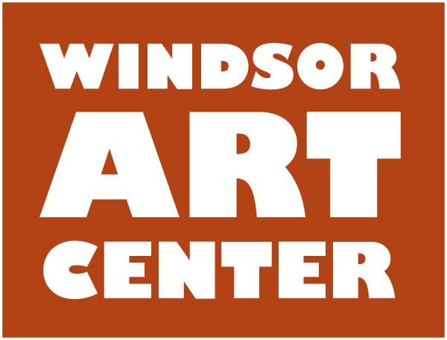
Press Release Contact: Ken Fredette
Immediate - Tuesday, October 24, 2017 413-297-2470

WINDSOR, CT. - The Windsor Art Center is excited to be hosting a sculpture show entitled Imagers in Conversation, beginning Saturday, November 11, 2017. The two sculptors featured in this exhibition are Delois Barnes and James Buxton. Both individually and together, their works spark and engage dialogue around societal issues.

The exhibition opens with a free public reception on Saturday, November 11, from 5:00 - 7:00 pm. The exhibition runs through December 23 at The Windsor Art Center, 40 Mechanic Street, Windsor, CT.

An Artist Talk presented by both artists, discussing their creative journey as sculptors in the 21st century, will be held on Saturday, November 18, from 2:00 - 3:00 pm. Gallery hours are: Thursday, 6:00 - 8:00 pm; Saturday, 10:00 am - 4:00 pm and Sunday, 11:00 am - 4:00 pm.

Additional events during the exhibition:

Saturday and Sunday, November 11 and 12 • 11am-4pm • Open Studios Hartford at the Windsor Art Center Studios
Art, Jazz, and Food at the Windsor Train Station with resident and visiting artists LeaAnn Cogswell, Cathy Doocy, Andres Chaparro, Joe Sam, Charlene Li, Kassie Huhtanen, and Robert Noreika.

Friday, December 1 • 6:30pm • Film Night
An old fashioned movie night with Popcorn and Pizza! FREE. A film about a renowned master artist whose sculptures of blown glass “Revolutionized the American studio glass movement.”

Saturday, December 9 • Noon-2pm • Workshop: “Cards that Pop”
3-D card-making workshop. Participants take home 3 handcrafted cards. Class held at the Windsor Art Center Studios. Class size limited to 10. $35 includes materials. Instructor: Meckla Pinnix-Clark.

This exhibition is made possible by the support from local businesses, organizations, and individuals from our community. The reception is sponsored by the Farmington Valley Chapter of The Links, Incorporated.

For more information, please call 860-688-2526 or visit www.windsorartcenter.org.

