**Ellsworth Memorial Association**

**Invites you to join us on**

**June 18, 2022 at 1:00 PM**

**For a Program on Connecticut Schoolhouses**

**Presented by Melinda K. Elliott**

**At the Oliver Ellsworth Homestead**

**778 Palisado Avenue**

**Windsor, CT 06095**

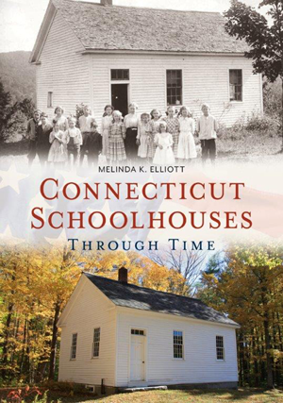

**There was a time when you could walk through Connecticut and find schoolhouses scattered everywhere. Each schoolhouse had one teacher who taught all the neighboring children ages 7-16. In 1852, there were over 1600 schoolhouses!**

**Author Melinda K. Elliott brings these schoolhouses to life in her book “Connecticut Schoolhouses Through Time” Book signing to follow.**

**Light Refreshments/Teacup Auction**

**Cost: $10.00 Fundraiser for Ellsworth Memorial Association**

**Ticket Sales: On line: *ellsworthhomestead*dar.org**

**Checks: Bonnie Butler, 237 Pumpkin Hill Road, New Milford, CT 06776 made out to Ellsworth Memorial Association OR EMA**

**Information: Bonnie Butler,** [**bbutler5129@gmail.com**](mailto:bbutler5129@gmail.com) **or 860-354-5129**