**Save the date!**

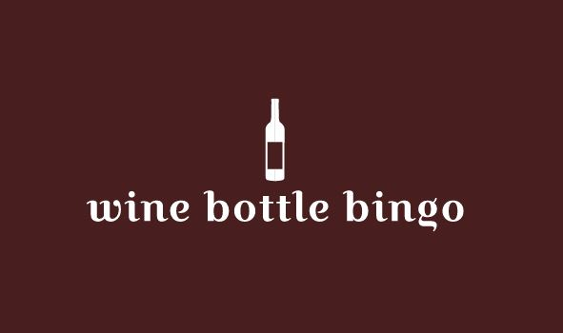

**Play BINGO. | Drink wine. | Win Prizes.**

**7:00 PM**

**September 13, 2019**

Note new location!

**Oliver Ellsworth Homestead**

778 Palisado Avenue

Windsor CT

A fundraiser for:



More information at [www.windsoreducationfoundation.org](http://www.windsoreducationfoundation.org)

21 and older event.