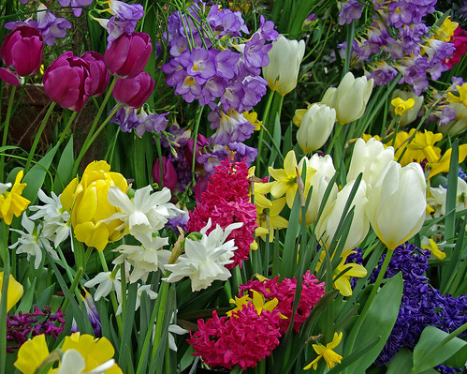

**The Windsor Lions Club**

**“Symbol of Hope” Fundraiser**  
  
The Windsor Lions Club is sponsoring a “No Contact” Spring Bulb Fundraiser. Working with, “Bulbs for Change”, from Middlebury Vermont, the Lions offer Spring bulbs of the highest quality, that can be ordered online. These bulbs and plants come from all over the world, are 100% guaranteed, and will be delivered directly to your home.  
  
Planted in the fall, these “symbols of hope” will bloom to brighten your garden and signify a new beginning for Spring of 2022. One hundred percent of the proceeds from this fundraiser support Lions global causes, hunger, pediatric cancer, vision, the environment and diabetes.  
  
For more information about the Windsor Lions Club, or with questions about this fundraiser, contact Lion Cindy Daniels, cldressage959@gmail.com

32125437<https://shop.giveandgarden.com/symbol-of-hope-fundraiser-129.html#!/Seller/174>

**Sale dates 08.12.2021 to 09.12.2021**