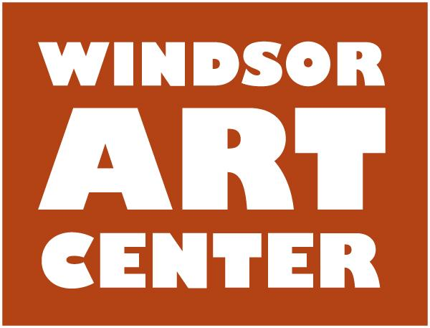

**Press Release**  Contact: Ken Fredette

Immediate - XXday, March XX, 2018 413-297-2470

**WINDSOR, CT** — On **Saturday, May 12,** The Windsor Art Center will be honored to open its exhibition of paintings by seven established, award-winning members of the Connecticut Plein Air Painters Society. *Out in the Open: A Connecticut Plein Air Landscape Exhibition,* which will run from May 12 through June 23, 2018, will include works painted outdoors in inspiring places around this small state. Artists Zufar Bikbov, Jack Broderick, Laura J. Eden, Robert Noreika, Elizabeth Rhoades, Shauna Shane, and Marilyn Swift have created works in a variety of media that will be on display. The **Opening Reception (free)** on **Saturday, May 12 from 5 – 7 p.m**. and a variety of artist talks, demonstrations, and workshops throughout the show, will be held at The Windsor Art Center, 40 Mechanic Street, Windsor, CT.

**Exhibition Events:**

* **Zufar Bikbov** will demonstrate landscape painting. Pre-Exhibition Event (Free): Sunday, April 29 from 1 p.m. to 3 p.m.

**Artist Talks (Free):**

* **Elizabeth Rhoades** will discuss her approach to plein air painting in pastel, on Saturday, May 12th at 1 p.m.
* **Marilyn Swift** will talk about *“Plein Air Painting: Its Challenges and Rewards,”* on Sunday, May 20th at 1 p.m.

**Workshops:**

* **Zufar Bikbov** will conduct *“Landscape Element: Painting Trees”* on Saturday, May 26, 10 a.m. to 4 p.m. This workshop is open to 12 participants. Fee: $125 plus $25 for materials.
* **Robert Noreika**will offer *Fearless Fluids in Arcylics or Watercolor*, a two-dayworkshop, on Saturday and Sunday, June 2 & June 3 from 10 a.m. to 4 p.m. Maximum enrollment: 12. Fee: $250.

**Artist** **Demonstrations (Free)**:

* **Laura Eden**, *The art of Egg Tempera*, on Saturday, June 9 at 1 p.m.
* **Jack Broderick**, *Landscape painting in oil*, on Saturday, June 16 at 1 p.m.
* **Shauna Shane**, *Acrylic sponge under-painting*, Saturday, June 23 at 1 p.m.

**About CPAPS**

CPAPS members range from beginners, who wish to learn the logistics and methods of plein air painting, to nationally recognized professional plein air artists who participate in competitive plein air events and actively exhibit and sell their work. CPAPS offers our members exhibition opportunities, demonstrations and workshops by both our Elected Artists as well as visiting national artists. The Connecticut Plein Air Painters Society supports and encourages painting

directly from nature and provides regular opportunities for members to paint together.

**Zufar Bikbov** graduated Cum Laude from Zelenodolsk Art School and continued self-education with leading artists of the City of Kazan in Studios of Fellowship affiliated with Saint-Petersburg Academy of Fine Arts (Russia). Zufar’s focus is Plein Air with moderate landscape abstraction. His “love of painting has been instrumental in shaping the direction of [his] life.”

**Jack Broderick** has traveled and painted extensively in Ireland, Argentina, Spain, Cuba and Italy. He has exhibited internationally in Paris, Tokyo, Buenos Aires, Palermo and Tilcara. Jack uses “both image and feeling in developing [his] paintings.” Currently he teaches painting and drawing at his studio in the Mill Works, Willington, Connecticut.

**Laura J. Eden** has been a full-time artist for 35 years, working in Egg Tempera since 2001. Laura’s paintings are meant to trigger daydreams, and her painting style merges the spontaneous inspiration from painting plein air with an intuitive fascination with detail, creating a distinctive style of realism infused with energy.

**Robert Noreika** is a graduate of Paier School of Art and has been a professional artist and instructor for over 40 years. His talent encompasses watercolors, oils, and fluid acrylics. A prominent national award-winning artist and illustrator, his paintings hang in both corporate and private collections throughout the United States, Europe, and Japan.

**Elizabeth Rhoades** is an award-winning Connecticut pastel artist known for her vibrant use of color and her sensitivity to natural light. In the past year, her stunning landscapes have garnered three awards from the Salmagundi Club, NYC, as well as four other major awards. She holds Elected or Signature Memberships in prestigious art organizations coast to coast.

**Shauna Shane** has been painting professionally for 36 years, beginning her career as Resident Artist at Yellowstone National Park. Working in a variety of mediums and informed by many years of painting from life, Shauna is able to communicate in her paintings – saturated with light and color – the emotion and unique atmosphere of a scene.

**Marilyn Swift**, born and raised in Connecticut, has lived and painted since 1974 in Gloucester, Mass. Travel has both challenged and inspired her creativity, and in recent years she has painted while traveling in Europe and South Africa. Watercolor is her preferred medium, but she paints with acrylic or oil if she feels either will better express her subject.

*This exhibition is supported in part by the Greater Hartford Arts Council’s United Arts Campaign; Dan J. & Alice Ford Ferraina; and other individuals, businesses, & organizations in our community.*

For the latest information and details, visit the website at **windsorartcenter.org or** call 860-688-2528. Exibition hours are: Thursdays, 6:00 - 8:00 pm; Saturdays, 10:00 am - 4:00 pm and Sundays, 11:00 am - 4:00 pm.