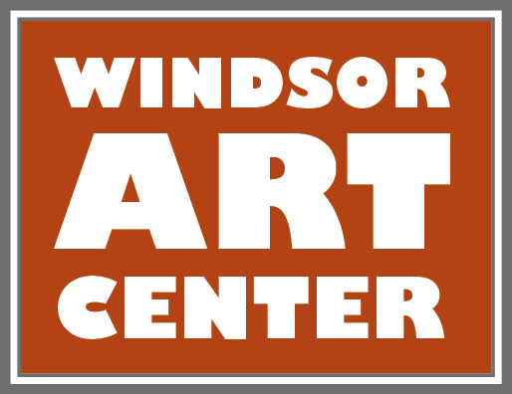

**Press Release**  Contact: Katherine Tolve

Immediate – DATE 860-748-0088

Windsor Art Center Opens New Exhibition on December 7th

The Windsor Art Center opens***Kiss My Black Art: Black Lives Matter, Selected Artworks*** by Joe Sam., internationally recognized mixed media artist and sculptor. The exhibition, which will run from **December 7, 2019 through January 11, 2020,** will be showing extraordinary work. Joe Sam., reveals his pride in his African American heritage, while suffusing his art with social and political commentary that encourages respect for all peoples. The influence of artists such as Jacob Lawrence and Romare Bearden is clear. This work testifies to Joe Sam.’s belief in the importance of portraying the unique African-American blended culture and of supporting those men and women who have committed their life’s work to doing so. Come experience the richness of the artwork by this renowned African American artist. It really matters.

**Events & Workshops**:

* **FREE public opening reception** and **meet the artist**: Saturday, December 7, 2019, 5 – 7:00pm.
* **Concert:** Sunday, December 8, 4-6pm: **The Morgan Giosa Blues Series with Marcia Gamache**
* **.** Cost $20 door; $15 for members
* **Concert:** Sunday, December 15, 7:00pm: **Holiday Concert with Judy Handler and Mark Levesque.** Cost $20 door; $15 for members
* **Workshop:** Wednesday, December 18, 6-8pm:  **Art Journaling** workshop taught by Karen Sprague, Cost $55 and includes all materials. Held at The Train Station Studios.
* **Panel discussion:** Thursday, December 19, 6:00-8:00pm: hosted by **Hartford Alumnae Chapter of Delta Sigma Theta Sorority, Inc.:**. Panel features Joe Sam and guests on civil rights and law enforcement within our communities. **FREE**
* **Performance: Stillness in Motion performance Vol lll- Friday/Saturday • December 27/28 6-8pm •** Live performance bridging the gap between the visual and performing arts crafted from the artwork &stories of the artists in each exhibit. Suggested donation $20/door.
* **Nutmeg Collective Pop Up Market:** Saturday, December 21, 10:00-3:00pm: Featuring high quality locally – made artisan and vintage goods. **FREE**
* **Artist Talk:** Saturday, January 4, 2-3:30pm. Joe Sam. will speak about his artistic journey and current body of work. **FREE**
* **Performance by Kimberly Cannon**, Fridy, January 10, 6:00-8:00: A one women show based on her book, *Out the Corner of My Eye.* Please visit [www.windsorartcenter.org](http://www.windsorartcenter.org/) for advance ticket sales and pricing. Cost $20 door; $15 for members.
* **Concert:** Sunday, January 19, 2:00pm: CT Guitar Society presents **Doug Maher Duo**. Cost $20 door; $15 for members

**About the Artist**

Born in Harlem, Joe Sam. was influenced by his early experiences and later by artists such as Jacob Lawrence and Romare Bearden. During his many years living and working in the San Francisco area, Joe Sam. earned an international reputation as not only a prolific fine artist, but also a public artist and an award-winning illustrator of children’s books. A number of years ago, while maintaining his west coast studio, he returned to the east coast to create an additional studio closer to his children. He also wanted to focus primarily on further developing his fine art.

Truly a bridge-builder at heart, Joe Sam. passionately testifies in his art to the validity and importance of portraying the cultures of African Americans and all under-represented peoples.

Joe Sam. has a considerable following of collectors and contemporaries that he has known socially and professionally. He counts among them, Danny Glover, Leroy Lendo, Nancy and Paul Pelosi, Bobby McFerrin, Betye Saar, Faith Ringgold, Raymond Saunders, Romare Bearden, Kehinde Wiley, and many other notables in art and jazz.

About the Musicians

**Morgan Giosa** is a 27 year-old web developer, blues guitarist, photographer, and visual artist from Windsor, Connecticut. He and his brother Alex, a professional drummer, were raised around music and the arts. Early on, Morgan discovered and developed his own passion for blues guitar. A self-described “old soul,” Morgan’s music is rooted in the 1960s’ electric psychedelic blues of artists such as Michael Bloomfield and Jimi Hendrix as well as in the music of the great electric bluesmen, B.B. King and Albert King. Morgan’s music ultimately comes to him spontaneously from his unique and unconventional intuition, emotions and life experiences. Morgan and his band, The Fake News Blues Band, released their first CD in 2019.

**Tommy Whalen** has performed locally and internationally as a long-time lead guitarist for Eight to the Bar. He currently fronts the band Tommy Whalen and the Ragged Edge, which plays a mixture of blues and rock music. He is also a continuing host guitarist at The Hungry Tiger and Black Eye Sally’s.

**Doug Maher** is originally from Windsor, CT. He has over 40 years of experience as a professional guitarist performing throughout New England, Washington, D.C. and South Florida. He began his career with "The Army Blues," the Jazz Ensemble of the U.S. Army Band in Washington, D.C. performing at The White House and in concert throughout the United States. Doug is currently the Adjunct Instructor of Guitar and Jazz Combo at the University of Connecticut.

*This exhibition is made possible with support by: Farmington Valley Chapter of The Links, Incorporated (opening reception host); Hartford Alumnae Chapter of Delta Sigma Theta Sorority, Inc.; Hartford Hospital; Dan J. & Alice Ford Ferraina and other individuals, businesses, & organizations in our community.*

The Windsor Art Center, Windsor, Connecticut, is a nonprofit organization that promotes the visual and performing arts and presents visual art exhibits showcasing the works of a variety of artists working in diverse media and genres. There is no charge to visit the gallery or the on-site gift shop which features locally made art. Parking is free and easily accessible. For more information on the exhibition, scheduled programs and exhibits, membership, and performing or exhibiting in the gallery, visit [www.windsorartcenter.org](http://www.windsorartcenter.org/).