Presented by THE HARTFORD AND INTEGRITY GRAPHICS, INC.

A 5K Road Race to Benefit the Windsor police cadets...
Date: Saturday, April 22, 2017
Location: Oliver Ellsworth School, 730 Kennedy Road, Windsor, CT
Time: Race starts at 10:40 AM (RAIN or SHINE)
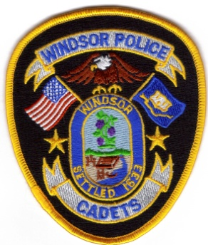
Registration: 8:30 AM to 10:30 AM
Fee: $20.00 Pre-registration ($25.00 after APRIL 15, 2017)

Race Highlights: CHIP TIMING, D.J., Easy On-Line Registration;
FREE INJURY ASSESSMENT & PRE/POST-RACE MASSAGES;
GOODIE BAGS (FIRST 100 TO REGISTER) pre-race warm-up; refreshments;
t-shirt (first 50 to register).

Awards: Best Overall Male & Female; “Top 3 individuals” in Each Age Division
For More Information check out www.windsorpolicecadets.org
- - - - - - - - - - - - - - - - - - - - - - - - - - - - - - - - - - - - - - - - - - - - - - - -
Mail Registration & Entry Fee to: Officer Bernard Petkis, 340 Bloomfield Ave, Windsor, CT 06095

Make Checks Payable to the “Windsor Police Cadets, Inc.”

First Name |  |  | Last Name
Address
City |  | State |  | Zip | Race day age
Sex M F  (circle One) |  | Date of Birth |  | T-Shirt Size s m l xl  (circle one)
I, ___________________________________________________, the undersigned by registering for the 1040EZ Run (Windsor Police Cadets 5K Race), understand the nature and risks associated with participation in this activity. I am aware that participation is at one’s own risk. I acknowledge that the activity, equipment, and facilities may pose significant risk of personal injury. I am also aware that each participant is responsible for his or her own safety. I hereby grant myself, as well as, my heirs, executors, and administrators, to waive and release any and all claims of damage we have ever had or now have, against the Windsor Police Cadets, Inc. and its board of directors; the Windsor Police Cadets and its advisors and volunteers; the Town of Windsor and it’s officials, as well as, all personnel of the Town of Windsor; and TIMING PLUS NEW ENGLAND for any and all kinds of injury, including but not limited to personal injury and/or property damage suffered by myself, while participating in this activity. I understand that the Windsor Police Cadets, Inc., Windsor Police Cadets, the Town of Windsor, and the Last Mile Race Management Co. are not responsible for medical, hospital, emergency room, or transportation expenses for any incidental illness or injury to the above named participant.

I certify that the information contained on this form is accurate and complete.

Signature: ___________________________________________________ Date: ___________________________
(Parent or Guardian if under 18)

