1040EZ Run
Presented by THE HARTFORD AND INTEGRITY GRAPHICS, INC.
A 5K Road Race to Benefit the Windsor police cadets
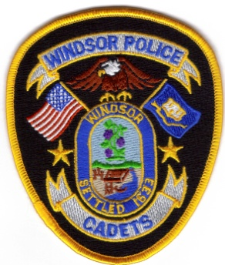

Saturday, April 22, 2017
Oliver Ellsworth School, 730 Kennedy Road, Windsor, CT

Race Starts at 10:40 AM (RAIN or SHINE)
Registration 8:30 AM to 10:30 AM

$20.00 Pre-Registration ($25.00 after APRIL 15, 2017)

Race Highlights
CHIP TIMING Easy On-Line Registration MUSIC
FREE INJURY ASSESSMENT & PRE/POST-RACE MASSAGES
GOODIE BAGS (FIRST 100 TO REGISTER)
PRE-RACE WARM-UP REFRESHMENTS T-SHIRTS (FIRST 50 TO REGISTER)

Awards

-Best Overall Male & Female-

-“Top 3 individuals” in Each Age Division-

For additional information or to register on-line check out www.windsorpolicecadets.org

