**Saturday, August 21**

**9 a.m. to Noon**

Meet at First Church parking lot next to the cemetery

69 PALISADO AVENUE

WINDSOR, CT

Palisado Cemetery Photo Day

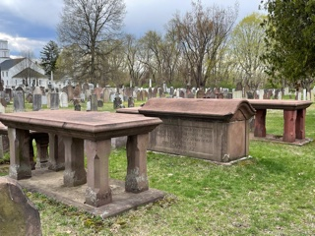

**VOLUNTEERS NEEDED**

**History Buffs and Photographers**

Locate and photograph gravesites in Windsor’s oldest cemetery. Photos will be submitted to the Find a Grave website.

Advance Registration and information: additional information:

tslewis4@gmail.com

**Hosted by the**

**Abigail Wolcott Ellsworth Chapter, DAR**

**Windsor, CT**



