**The Not-S0-Golden Life**

**of the Gilded Age Wife**

The **Grounded Goodwife** Returns to Windsor

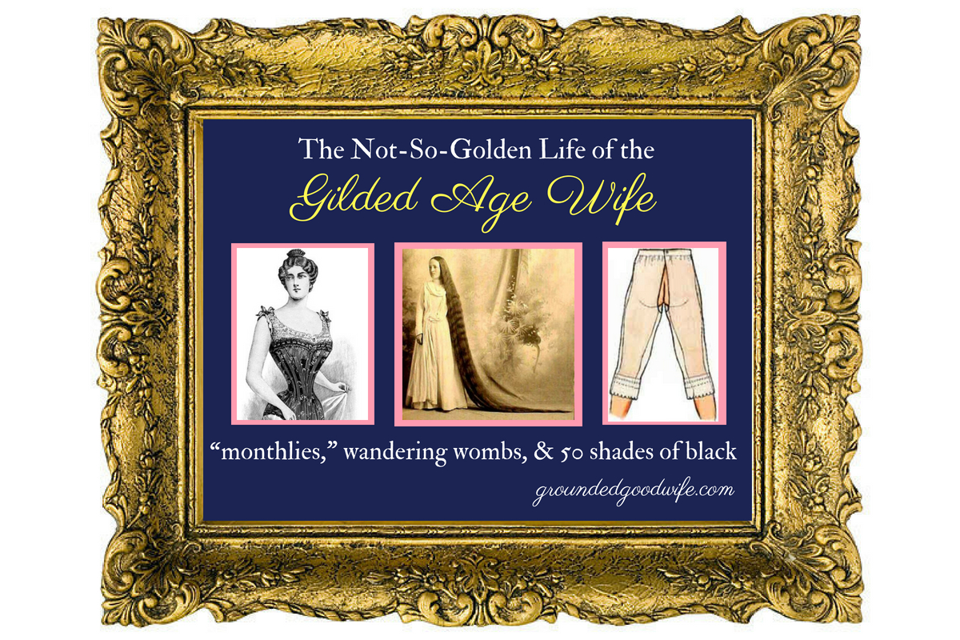

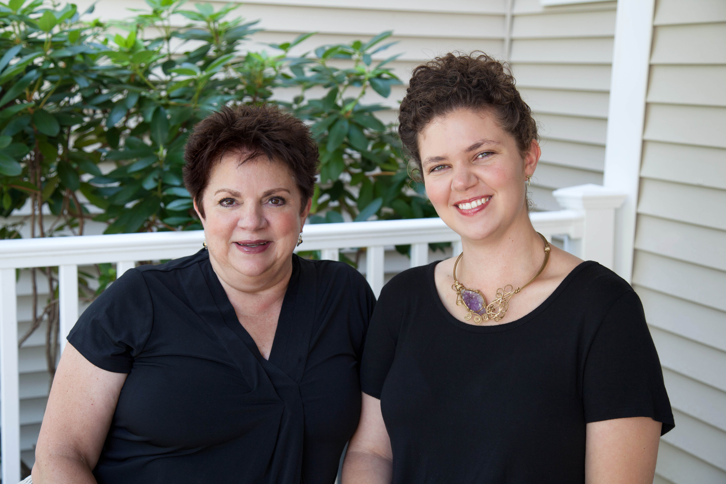

**Discover what life was really like for women in America’s Gilded Age. Presented by well-known authors and speakers Velya Jancz-Urban and daughter Ehris Urban.**

Groundedgoodwife.com

*Some of the most interesting things in history are omitted because they’re taboo. Laugh and grimace about the little-known women’s issues of the Gilded Age. This is “Herstory Unsanitized”.*

**Sunday, Sept. 15, 2019 at 2 p.m.**

**Ellsworth Homestead, 778 Palisado Ave.,Windsor**

**Tickets $10 at the door or advance purchase online**

**ellsworthhomesteaddar.org**

**Appropriate for adults and teens**

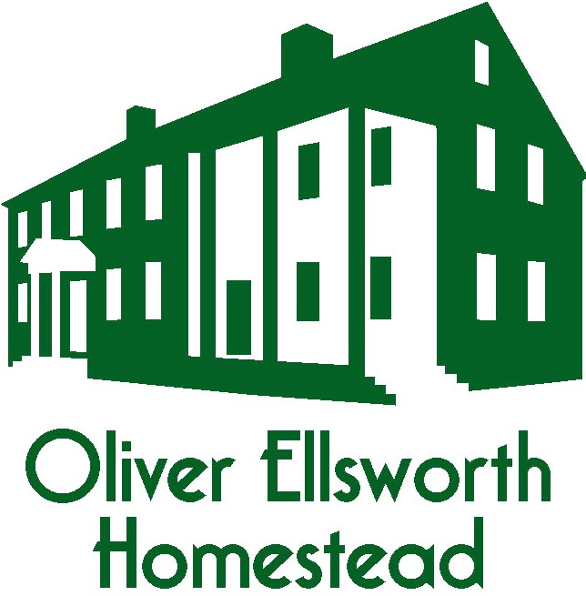

Proceeds benefit the Oliver Ellsworth Homestead