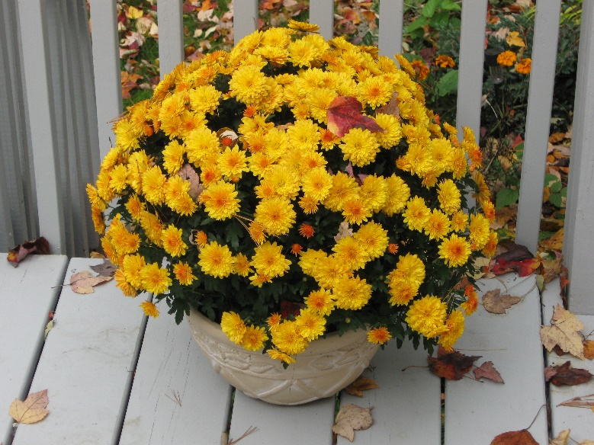

**MUMS ON THE GREEN!**

BEAUTIFUL, GIANT MUMS WILL BE SOLD BY THE

**WINDSOR WOMAN’S CLUB**

ON THE WINDSOR TOWN GREEN

SATURDAY, SEPTEMBER 11, 2021

FROM 10AM TO 2 PM

FOR THE BARGAIN PRICE OF 3 FOR $18

ASSORED COLORS

IN FRONT OF THE EAGLE!!