For Immediate Release

Media Contact:

Patricia Gardner

860-997-5281

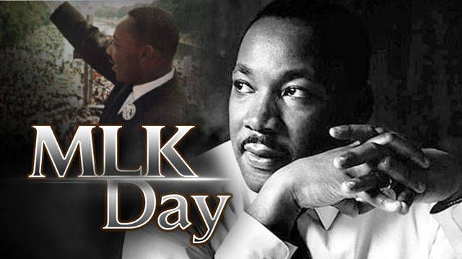

Dr. Martin Luther King, Jr. Celebration in Windsor, January 20, 2020

The Archer Memorial A.M.E. Zion Church is sponsoring its' annual Dr. Martin Luther King, Jr. Celebration for the community on **Monday, January 20, 2020, 2:00p.m.-3:30pm at the Windsor Town Hall Council Chambers, 275 Broad Street in Windsor, CT**. The keynote speaker for this annual event will be Liana Jorgensen, Principal of Sage Park Middle School who has served as an educator and leader in the Windsor school district for over 17 years. The program will also include special tributes to Dr. King with words of reflection and musical selections.  All are welcome as the community comes together in commemoration of Dr. Martin Luther King Jr.’s dream, life, and legacy.  The event is free and is open to the public. Refreshments will be served after the program. For questions, please contact the Archer church office at 860-688-5225.

-End-