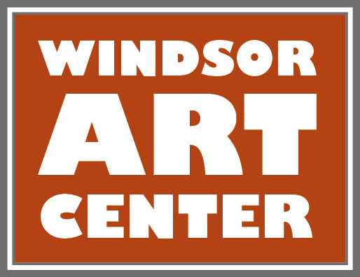

**Press Release**  Contact: Katherine Tolve

Immediate -  DATE 860-748-0088

Windsor Art Center Opens- Self Preservation: An Artist’s Selfie

Join us in celebrating the works of over 50 distinguished Connecticut Artist!

Runs October 12th-November 23rd

“If you could leave one image of yourself for the rest of the world to judge you by, what would it be? Is their one picture that would sum you up? In the 21st century we make images of ourselves all the time, we are all self portraitist now.” *Ego, The strange and Wonderful world.*

A self-portrait is a representation of an artist created by that artist. Self-portraits are made in every medium imaginable – photographs, paintings, drawings, sculptures, and many more. If you’re an admirer of art, and have frequented museums and galleries, you’ve most likely seen quite a few self-portraits. Artists from all over Connecticut have been invited to participate in this reflective and introspective exhibition. Artist showcase their individuality and unique style while revealing insight into a creative process of self-discovery and realization. The cross disciplinary exhibition will include the styles of realism, abstraction, traditional, nonrepresentational, modern, and conceptual spanning the timeline of almost 25 years. Visit us online to see participating artists!

Several events/workshops will complement the exhibition.

* Exhibition opens with a **FREE public reception**: Meet the artist’s- Saturday, October 12, 2019 from 5-7:00pm
* Sunday October 13 • 4-6pm • **The Morgan Giosa Blues Series,** The Fake News Blues Band will perform in a four-concert programincluding Nov.10 & Dec.8. Cost is $20 at the door; $15 for members.
* **Little Artist program- taught by Katherine Tolve** Thursday October 17th, 11:00-12:30 p.m. By creating a self-portrait, children learn who they are, how they want to present themselves and what's important to them. Drawing a self-portrait is also excellent for teaching children that these personal ideas aren't the same as what everyone thinks. Using the current show’s backdrop for discussion and inspiration little artists will enjoy story time and a craft. All ages welcome! **FREE.**
* **Adult Portrait Painting Workshop- Taught by Michelle Hawran,** October 20th from 12-4 pm, $70 includes all materials.
* **Film Friday:** Ego: The Strange and Wonderful World; Enjoy an old fashion movie night with popcorn and pizza!, Friday October 18th 6:00-8:00, **Free**,

* **Stillness in Motion- Vol 2**: An explorative theatrical experience based on the stories and pieces of the Self Preservation exhibit. Thursday-Friday • November 14&15 6–8pm **Suggested donation-$15 at the door**
* **Artist Talk/Panel discussion:**  Saturday Nov. 23rd, from 2:00-3:30 Select artists will discuss portraiture in the 21st century, **FREE**
* **The Nutmeg Collective Pop Up Market:** Enjoy shopping**!** The Nutmegcollectivefeatures high quality locally made Artisan and vintage goods. Saturday Nov. 30th from 10:00-3:00 **Free**

Located in Windsor, Connecticut, the Windsor Art Center is a nonprofit organization that promotes the visual and performing arts and presents visual art exhibits showcasing the works of a variety of artists working in diverse media and genres and hailing from throughout New England and beyond. Artist “talks” and children’s activities complete the annual programming. There is no charge to visit the gallery or the on-site gift shop which features locally made art. Parking is free and easily accessible. For more information on scheduled programs and exhibits, membership, and performing or exhibiting in the gallery, visit [www.windsorartcenter.org](http://www.windsorartcenter.org/)

*This exhibition is made possible by a grant from the Roberts Foundation; and additional support by Hartford Hospital, Dan J. & Alice Ford Ferraina and other individuals, businesses, & organizations in our community.*

For more information, please call 860-688-2526 or visit www.Windsor Art Center.org.