 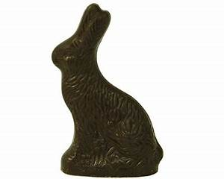

 The Windsor Lions Club, Offers a Sweet Deal

The Windsor Lions have served the Windsor Community for 70 years and have teamed with Munson’s Handcrafted Chocolates, voted “Connecticut’s Best” year after year for an amazing fundraiser!  Since 1946, Munson’s has offered only the highest quality chocolate, made locally. The Windsor Lions will use 100% of the proceeds from this unique fundraiser to support the Windsor community. In order to guarantee only the finest traditional chocolate and specialty Easter items, you may order online from February 15th to March 23rd. only. All orders will be available for pick up on the Windsor Town Green, at our Windsor Lions Annual Plant Sale, on Thursday, April 14th thru Saturday, April 16th. Thank you! Please contact Cindy Daniels, [cldressage959@gmail.com](mailto:cldressage959@gmail.com) with any questions.

The link to the site where you can place your order is provided below.  Please share this with your friends, family members, neighbors, etc. so they can place their orders by March 23rd.

<https://windsor-lions-foundation-windsor-ct.square.site/>